Parent Engagement – Yoga Series
You are invited to join us for a series of 3 evening workshops
for the whole family entitled “Helping Families Thrive!”
These workshops are designed with the whole family in mind offering an opportunity to have fun together in a safe, supportive environment. This series of workshops is offered by your School Council!
Join us for one, two or all three workshops. Each evening will offer a fun, family yoga class along with some related hands on activities for the children and discussion for the adults designed to encourage you to embrace a healthy, joyful living for the whole family.
Yoga experience is not required. Please come dressed in comfortable attire. Mats will be provided or feel free to bring your own.
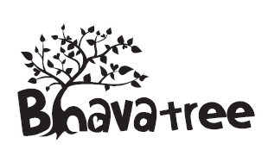 empowering Children from the Ground Up
Sheryl is a qualified teacher with many years of experience working with children in and out of the classroom. She is a HeartRise Yoga for Children Teacher Training Graduate who is passionate about empowering children to recognize their greatness and live life as happy, healthy, balanced individuals. Bhava Tree was created to help children embrace the benefits of living life with a wellness attitude. www.bhavatree.com
Registration is required in order that we can prepare and provide refreshments for the children and take-home materials. We are excited to offer this series at both schools to provide you with alternate dates to choose from.

Please check the boxes below to show the evening(s) you will attend and indicate the number of adults and children attending. These events are no charge.
RETURN this form to your home school by MAY 1st
^{Student’s Last Name:} ^{Student’s First Name:}
**Workshops run from 6:30 - 8:00 pm at the school**
Name of Workshop | St. Patrick’s | Notre Dame | # of  Adults | # of Children
Family Yoga  + Making Healthy Food Fun for Everyone! | Wednesday, May 9 | Tuesday, May 8
Family Yoga  + Managing Stress for All Ages | Wednesday, May 16 | Tuesday, May 15
Family Yoga  + Finding Happiness with Mindfulness | Wednesday, May 23 | Tuesday, May 22

